**NELTecnológico de Monterrey**

**School of Engineering and Sciences**

**Embedded Systems Alfonso Avila**

**InClass: Serial communications**

**IC1 Fill the comparison table**

|  |  |  |  |  |  |  |
| --- | --- | --- | --- | --- | --- | --- |
| **Serial protocol** | **# masters** | **#**  **slaves** | **Synch/**  **Asynch** | **#**  **cables** | **Terminal**  **names** | **Baud**  **rate** |
| **SPI** | **1** | **Multiples** | **synch** | **4+gnd** | **Sclk mosi/simo**  **Miso/somi**  **ss** |  |
| **I2C** | **1** | **128** | **synch** | **2+gnd** | **SDA SCL GND** | **3.4MHz** |
| **UART** | **1** | **1** | **Async** | **2+gnd** | **Rx tx** | **9.6KHz** |

**IC2 Identifying data packet in the serial port**

The following C code was executed:

***myprintf(“A”);***

**a) Determine the transmission parameters**

Determine info about the baudrate, parity, frame size and stop bits. Report this info.

9600, none, 8 bits, 1 stop bit

**b) Observe and draw the oscilloscope waveform**

If an UART packet is described as indicated in this figure. 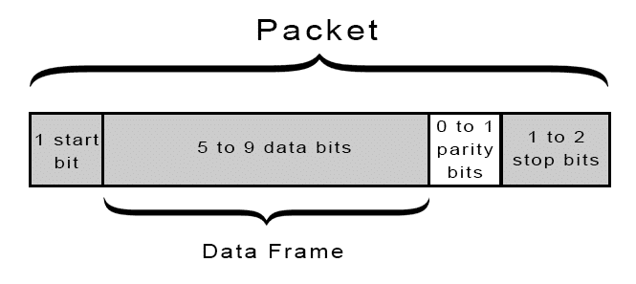

Draw the packet observe in the oscilloscope and different bits defining the packet. Show your drawing to your professor. Report an photo/image of the oscilloscope image.

**c) Interpret the signal**.

Looking at the drawing, obtain the bit sequence of the packet and demonstrate that the letter A is being transmitted.

**d) How to measure the baud rate?**

Describe the procedure and include an oscilloscope picture with the measurement.

**IC3 Identifying data packet in the i2c bus**

The following C code was executed

***while (1) {***

***/* Sending slave address in write mode */  
 SERCOM3->I2CM.ADDR.reg = (SLAVE_ADDR << 1) | 0;   
 while(SERCOM3->I2CM.INTFLAG.bit.MB ==0);***

***/* Sending address for internal pointer */  
 SERCOM3->I2CM.DATA.reg = 0xFF;***

***while(SERCOM3->I2CM.INTFLAG.bit.MB ==0){};***

***/* Sending stop condition */  
 SERCOM3->I2CM.CTRLB.bit.CMD = 0x3;***

***}***

**a) Relation code vs packet structure**

If an I2C packet has the bits as indicated in this figure. What portions of this figure relate to the C code.

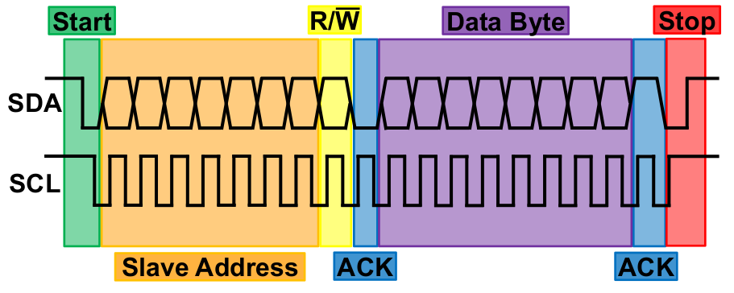

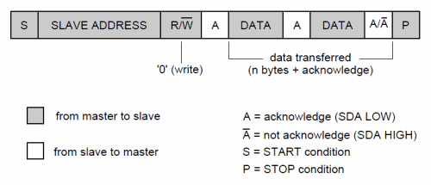

**What is the slave address?**

**Does the packet imply a read or write operation?**

**What is the data being transmitted?**

**100kb/s, 8-bit,**

**b) Observe the oscilloscope**

Draw the packet observe in the oscilloscope and different bits defining the packet. Show your drawing to your professor. Report an photo/image of the oscilloscope image.

**c) Interpret the signal**.

Looking at the drawing, obtain the bit sequence of the packet and demonstrate that the slave address and data are being transmitted. Mark in the drawing the bits related to the slave address, r/w, acknowledge, data, etc.